FIGURE 1

In some states most high school graduates take the SAT test as part of their college application process, and in other states most take the ACT. How popular the SAT is in a state (i.e., the percent of students who take it) may influence the state’s average score. We would like to investigate this relationship, specifically with math SAT score. The information below is from 2007 and contains all 50 states, plus Washington, D.C.



min Q1 median Q3 max mean sd n

Percent taking SAT 3 8 32 68.5 100 39.333 31.123 51

Average state score 462 507 526 568 613 538.06 39.246 51

on math SAT

Regression output: average state math SAT score = 581.00 - 1.092(Percent taking SAT)

Correlation = -0.866

FIGURE 2

FIGURE 3

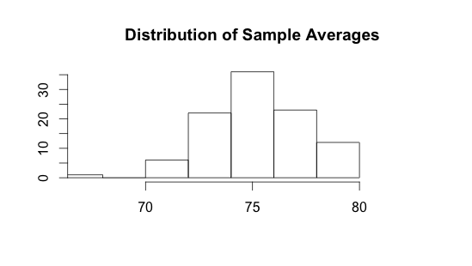

FIGURE 4

FIGURE 5

FIGURE 6

A business school with 1400 students sends questionnaires to all of the students in its four majors: Accounting, Economics, Administration, and Marketing. If a student doesn’t respond to the questionnaire, the school follows up with a phone call, in an attempt to reach every one of their students. Of the 1400 students, 123 responded to the survey (either via questionnaire or phone). The responses are below.   
Assume that a student can not pick more than one major (no double majors).

|  |  |  |  |  |  |
| --- | --- | --- | --- | --- | --- |
|  | Accounting | Economics | Administration | Marketing | Total |
| M | 20 | 35 | 15 | 10 | 80 |
| F | 6 | 3 | 15 | 19 | 43 |
| Total | 26 | 38 | 30 | 29 | 123 |